**CAMPUS RECRUITMENT**

**Team Name: Pega Warriors**

**Team Members:**

1. **Y. V. Nithish Kumar**
2. **K. Tonesh**
3. **V. Arun Sai**
4. **K. Yogeswar Sai Manikanta**

**SCRUM Master: Y. V. Nithish Kumar**

**Product Owner: Arpita Gupta**

**Application Structure:** Implementation **Application Name: Brighten Your Career**

**Use Case Description:**

Brighten Your Career is a Campus Recruitment Application. This application helps to streamline the recruitment process for both students and companies. The application will allow companies to register for campus placements, students to create profiles and enroll for placements, and placement team members to record interview results and announcements. It aims to bridge the gap between academia and corporate world by facilitating seamless interactions, fostering meaningful connections and enabling a smooth hiring process.

**At a high level and with the initial phase I release, this application will:**

1. Allows students to **create profile** for themselves.
2. Allow **companies to register** themselves for campus recruitment.
3. Allow **College management to review** the Companies proposals and accept /reject the company registration.
4. Allow Students to **enroll for Campus Placement**.
5. Allow Company Panel Manager to **Schedule the interviews.**
6. Allow Company Panel Members to **record results of the interview**.
7. Allow College management to record results and announcements

**Actors:**

* 1. **HR Company person** (Handles companies registration, provides slot preferences and selection criteria, receives interview result and feedback)
  2. **Student** ( Creates a profile ,enrols for placements , attends pre-placement talks, Written test and interview)
  3. **Placement Team** ( Provides support during interview and tracks students placement outcomes)
  4. **Placement O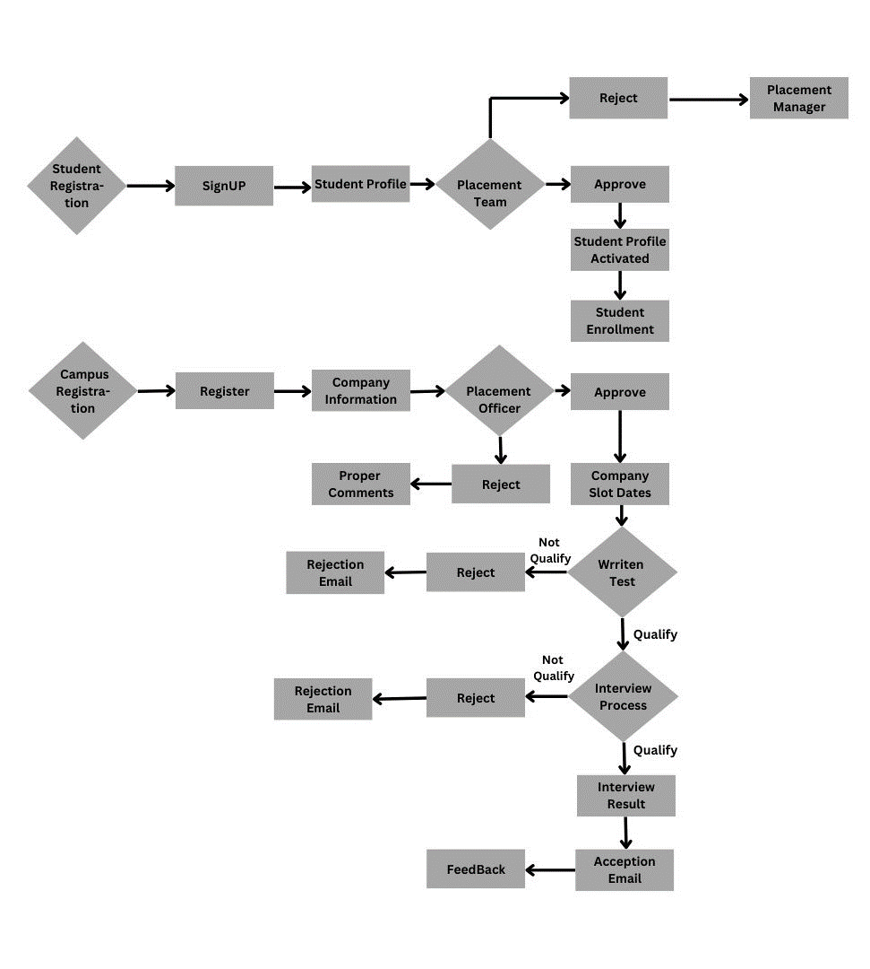fficer** ( Develops and implements campus recruitment strategies, manages relationship with companies and analyses placement data)
  5. **Panel Member** ( Evaluates candidates and provides interview results)
  6. **Developer** ( Manages the application process for campus recruitment)

**ECS :**







**Flow of our case:**

**Data Types used in the Brighten Your Career Application:**

1. Student Details
2. Company Details

**Portals:**

# Student

Home Portal_ Students have access to unauthenticated portal to login/Signup.

# Company

Home Portal_ To Register for interview

# Placement Team

To accept the request from students and company

To accept or Reject the company final proposal

To Provide Feedback for Company

# Pannel Members

To conduct interview and give feedback on Candidate.

**Access Group:**

# BYC : Student

1. BYC : Company
2. BYC : Team
3. BYC: Manager

**Work Group:**

1. Panel Work group
2. Placement Work Group

**Sample Operators:**

| **ROLE** | **OPERATORS** |
| --- | --- |
| Developer | Developer@BYC |
| Users | Student@BYC |

**Regards:**

Team Pega Warriors